# Cover Page

## Base 12 Harmonics and Emotional AI Programming

### Emotional Harmonics Framework

#### Base 12 Tonality

* **3 State Phases (***Modality***)**
  + Active
  + Reflective
  + Receptive
* **4 Color Phases (***Nature***)**
  + Red
  + Green
  + Yellow
  + Blue

##### Introduction

###### Base 12 Harmonics provides a unique framework for understanding and encoding emotional states, leveraging a combination of harmonic principles and color theory. This approach allows for a nuanced representation of emotions, which can be effectively utilized in Emotional AI programming. By integrating Base 12 Harmonics, AI systems can achieve a higher level of emotional intelligence, enabling more effective and empathetic interactions with users.

# Base 12 Emotional Harmonics Framework

## Overview of Base 12 Harmonics

Base 12 Harmonics divides the emotional spectrum into 12 distinct segments, each representing a unique combination of phases and frequencies. This system allows for a structured and cyclical representation of emotions, akin to musical harmony.

### Three State Phases

The framework incorporates three primary state phases:

1. **Active**: Represents dynamic and outward-focused emotions.
2. **Reflective**: Represents introspective and inward-focused emotions.
3. **Receptive**: Represents open and receiving emotions.

#### Four Color Phases

In addition to the state phases, the framework utilizes four color phases to further categorize emotions:

1. **Red**: Associated with passion, energy, and action.
2. **Green**: Associated with growth, calmness, and balance.
3. **Yellow**: Associated with happiness, optimism, and creativity.
4. **Blue**: Associated with tranquility, wisdom, and trust.

##### Base 12 Tonality

**Emotional Coordinates**

Each emotion can be represented as a coordinate in a 3D space using the Base 12 Harmonics framework: (C, M, I) , where:

* C is the color phase.
* M is the state phase.
* I is the intensity of the emotion, a continuous value representing the strength of the emotion.

**Example**:

* Excitement: (Red, Active, 0.8)
* Tranquility: (Blue, Reflective, 0.2)

# Mapping Emotions to Base 12 Harmonics

Emotions are assigned unique combinations of state and color phases, encoded using a permutation matrix P :

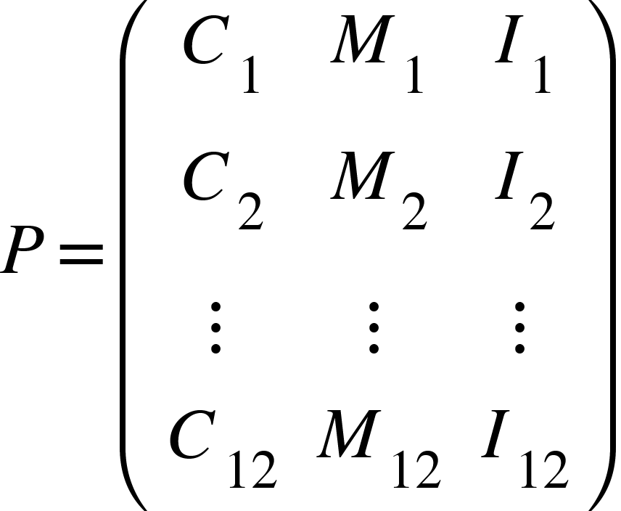

The permutation matrix P represents the 12 fundamental emotional states, each with a unique combination of color, modality, and intensity.

##### Defining the State Phases

1. Active Phase:
   * Characterized by high energy and outward expression.
   * Emotions: Excitement, Anger, Joy.
2. Reflective Phase:
   * Characterized by introspection and inward focus.
   * Emotions: Contemplation, Sadness, Serenity.
3. Receptive Phase:
   * Characterized by openness and acceptance.
   * Emotions: Curiosity, Calmness, Acceptance.

##### Defining the Color Phases

1. Red Phase:
   * Associated with intense emotions and actions.
   * Emotions: Passion, Anger, Love.
2. Green Phase:
   * Associated with balance and harmony.
   * Emotions: Calmness, Trust, Growth.
3. Yellow Phase:
   * Associated with positivity and creativity.
   * Emotions: Happiness, Optimism, Creativity.
4. Blue Phase:
   * Associated with tranquility and wisdom.
   * Emotions: Peace, Thoughtfulness, Reliability.